STRIPE INTEGRATION

*22.3.0*



Table of Contents

1. Component Overview 3

Functional Overview 3

Use Cases 3

Limitations, Constraints 3

Compatibility 3

Privacy, Payment 4

2. Implementation Guide 5

Setup of Business Manager 5

Configuration 6

Stripe Quick Setup 8

Stripe Dashboard 8

Custom Code 11

External Interfaces 18

Firewall Requirements 20

Stripe Payment Element 20

Stripe Radar Insights Display 21

Alternate Payment Methods 22

ACH Debit 22

WeChat Pay 24

Klarna 25

Multibanco 26

Manage Refunds 27

Gift Certificates 28

3. Testing 29

4. Operations, Maintenance 30

Data Storage 30

Availability 30

Failover/Recovery Process 30

Support 30

5. User Guide 32

Roles, Responsibilities 32

Business Manager 32

Storefront Functionality 33

6. Known Issues 35

7. Release History 36

# **Component Overview**

## Functional Overview

Stripe Elements and Sources

Stripe Elements modifies the default Commerce Cloud Credit Card collection and processing by using Stripe.js, a JavaScript library, to securely tokenize credit card data. Payments are then processed using the tokenized data, not the raw credit card information.

During checkout, the cartridge will create a source for any new cards or alternate payment methods entered by customers. This data is transformed into a Stripe Source. At the point of purchase, the stored, tokenized data is used to generate a Stripe Charge. Registered Customers can manage (add, delete) reusable payment methods in their storefront-connected Stripe Account for re-use in subsequent storefront purchases.

## Use Cases

Stripe.js Sources

When customers enter credit card or other payment information on the storefront, the information is tokenized via Stripe.js in a client (browser)-to-Stripe interactions. Unmasked credit card data is therefore never sent to the Commerce Cloud servers.

Stripe Charges

System will create a Stripe Charge (authorize or capture, based on Business Manager configuration) from a successfully created and submitted Basket. All Stripe Charges are created against a Stripe payment Source.

AVS Auto-Fail Transactions

Site administrators can select a variety of AVS statuses for which an Order should be auto-failed. If the Stripe Charge returns any of the selected statuses for either address_line1_check or address_zip_check the Order will be auto-failed and the Stripe Charge reversed. Note that these settings can also be managed on the Stripe Dashboard.

Supported payment methods:

* Cards (Visa, Mastercard, American Express, Discover, Diners Club, JCB) Alipay
* The Payment Request Button Element gives you a single integration for Apple Pay, Google Pay, Microsoft Pay, and the browser standard Payment Request API.

## Limitations, Constraints

*Stripe offers a number of standard services that are not supported by the cartridge. These include support for Subscriptions, Plans, and Coupons.*

*The included RELAY OCAPI configurations are included as examples only. A RELAY implementation will require additional configuration and testing along with the Stripe team.*

*For any locale specific restrictions, please refer to* [*https://stripe.com/docs/js*](https://stripe.com/docs/js)*.*

## Compatibility

*Available since Commerce Cloud Platform Release 16.8, Site Genesis 103.0.0*

*The cartridge is available for installations on storefronts that support both Controller and SFRA SiteGenesis implemenations.*

## Privacy, Payment

*No unmasked credit card data is stored within Commerce Cloud. The cartridge tokenizes all payment data via direct client-to-Stripe communications and obscures any sensitive credit card data before it arrives on the Commerce Cloud servers. Similarly, all credit card data that is retrieved by Commerce Cloud from the Stripe servers is also masked and/or tokenized.*

# Implementation Guide

## Setup of Business Manager

*The Stripe LINK Cartridge contains several cartridges that are required for full functionality. Additionally, Controller and SFRA support is broken out into two separate cartridges, thereby facilitating the installation and use of one or the other models.*

*Import all three cartridges into UX studio and associate them with a Server Connection.*

*Site Cartridge Assignment*

1. *Navigate to Administration > Sites > Manage Sites*
2. *Click on the Site Name for the Storefront Site that will add Stripe Functionality*
3. *Select the “Settings” tab*
4. *For Controllers "app_stripe_controllers:app_stripe_core:int_stripe_controllers:int_stripe_core" need to be added to the cartridge path*
5. *Repeat steps 2 – 4 for each Storefront Site where Stripe will be implemented*

*Business Manager Cartridge Assignment*

1. *Navigate to Administration > Sites > Manage Sites - Click on the Business Manager Site > “Manage the Business Manager site.” Link*
2. *Add “int_stripe_core” to the Cartridges: path*

*Metadata import*

1. *Navigate to the metadata folder of the project and open the stripe_site_template folder.*
2. *Open the sites folder and edit the 'siteIDHere' folder to the site ID of the site you want.*
3. *Add a folder for each site you need stripe on.*
4. *Navigate to Administration > Site Development > Site Import & Export*
5. *Zip the stripe_site_template folder and import it.*

*Building Stripe Styling*

*Copy app_stripe_core/cartridge/scss/default/stripe.scss into your app_storefront_core cartridge. Import the file on the bottom of style.scss and compile the CSS.*

*Add New Payment Processors*

*There are two payment processors used in the Stripe cartridge. “STRIPE_CREDIT” is used for credit card handling while “STRIPE_APM” is used for the asynchronous payment model (Bank transfers, GiroPay, etc).*

*If using Stripe credit cards, Navigate to Merchant Tools > Ordering > Payment Processors and click the "New" button. In the new window set the ID attribute to value "STRIPE_CREDIT" and click "Apply".*

*If using APM methods, again, click the "New" button. In the new window set the ID attribute to value "STRIPE_APM" and click "Apply". This payment method is for the non-credit card (APM methods)*

*Update Payment Methods*

*Navigate to Merchant Tools > Ordering > Payment Methods, click on the CREDIT_CARD payment method and select the STRIPE_CREDIT payment processor in dropdown under the CREDIT_CARD Details section*

*If using APM payment methods and/or the Payment Request Button then enable the desired payment methods as well: The STRIPE_APM_METHODS will provide the ability to include all of the supported Stripe methods. See* [*https://stripe.com/payments/payment-methods-guide*](https://stripe.com/payments/payment-methods-guide)

*To utilize the Stripe Payment Request Button, enable the “STRIPE_PAYMENT_REQUEST_BTN” payment method. See* [*https://stripe.com/docs/stripe-js/elements/payment-request-button*](https://stripe.com/docs/stripe-js/elements/payment-request-button)

*Alternatively, you can update payment-methods.xml with preferred Stripe payment methods which to import manually:*

*Alternatively you can configure Stripe in Business Manager using Stripe Quick Setup:*

*1. Login to your Business Manager and Navigate to ‘Administration > Sites > Manage Sites ‘*

*2. ‘Navigate to Manage the Business Manager site.’ -> click on ‘Business Manager’ link*

*3. Insert following cartridges in ‘Cartridges Path’*

*modules:app_storefront_base:int_stripe_core:bm_stripe*

*and Save changes*

*4. Go to Business Manager > Administration > Organization > Roles & Permissions ->* Administrator -> ‘Business Manager Modules’ Tab -> Select ‘Sites’ -> Check ‘Stripe Payment Methods Setup’

and Save changes

5. Navigate to Business Manager -> Merchant Tools -> Stripe -> Stripe Payment Methods Setup

Select/Unselect Stripe Payment methods you want to configure

*Click on ‘Generate XML File’ button and Download the payment-methods.xml file*

*6. Navigate to Merchant Tools -> Ordering -> Import & Export -> Upload and Import the payment-method.xml file*

## Configuration

Update the Merchant Tools > Site Preferences > Custom Site Preferences > Stripe Configurations with Site specific values.

1. [Stripe Secret API Key a. Can be obtained through the Stripe Dashboard (https://dashboard.st ripe.com/account/apikeys)](https://dashboard.stripe.com/account/apikeys)
2. Stripe Publishable API Key a. Find along with Stripe Secret API Key
3. Is this SFRA installation. Set to yes if the current site is using the Storefront Reference Architecture (SFRA)
4. Capture Funds on Stripe Charge a. Default value: true (Yes) b. Set to false (No) to instead Authorize Stripe Charges
5. Save Customer Cards to be able to re-authorize transactions after 7 days on Stripe side. a. Default value: Disabled. Set to ‘Always save cards’ will create customer on Stripe side and store card token for all Guess customer checkouts. Set to ‘Ask the customer’ will display a checkbox for guess customer checkout (‘Save card on Stripe for re-authorize payments’) and when guess customer checks it, it will create customer on Stripe side and store card token.
6. Stripe Card Element CSS Style a. Enter the CSS styling that the Card element button should inherit to fit within the overall storefront styles. Style Configuration for Stripe Elements e.g, {"base": {"fontFamily": "Arial, sans-serif","fontSize": "14px","color": "#C1C7CD"},"invalid": {"color": "red" } }
7. Stripe API URL - <https://js.stripe.com/v3/>
8. Stripe Payment Request Button Style a. For the payment request button, select the limited [CSS styling that the button should display with. See https://stripe.com/docs/stripe-js/eleme nts/payment-requestbutton#styling-the-element](https://stripe.com/docs/stripe-js/elements/payment-requestbutton" \l "styling-the-element)
9. ApplePay Verification String i. Enter the Apple verification string provided from the Stripe dashboard. ii. This is a one time enablement. The Stripe console will proxy the Apple Pay for Web verification String upon setup. This will need to be configured into the sandbox if the Payment Request Button will be used as a form of payment on the storefront.
10. Country Code (Stripe Payment Request Button) - Country Code e.g, US. This will be the default country code for the Payment Request Button. Customization may be needed on a multi country single site in order to dynamically pass the country code rather than the site [preference (if needed). https://stripe.com/docs/stripe-js/elements/payment-requestbutton# create-payment-request-instance](https://stripe.com/docs/stripe-js/elements/payment-requestbutton" \l "create-payment-request-instance)
11. Stripe Webhook Signing Secret i. Enter the webhook signing secret provided by the stripe dashboard. Stripe will sign webhook calls and pass a validation to SFCC. SFCC will validate the contents of the message via this key.
12. Stripe allowed Webhook Statuses i. Configure the allowed statuses for Webhooks to respond to.

Set to:

* review.opened
* review.closed
* charge.succeeded
* charge.failed
* source.canceled
* source.failed
* source.chargeable
* payment_intent.succeeded
* payment_intent.payment_failed

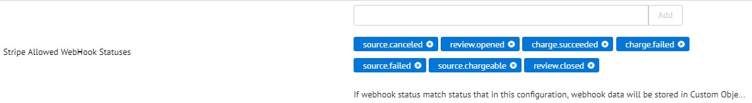

1. Allowed APM Methods a. Update this field, per site locale, to indicate which alternate payment methods are enabled for each locale. Enumeration of allowed Payment Methods from the Stripe API. See more here: <https://stripe.com/docs/sources>{ "default": [ "p24", "eps", "sepa_debit", "ideal", "sofort", "bitcoin", "alipay", "bancontact", "giropay" ], "en_UK": [ "p24", "eps" ], "de_AT": [ "sofort", "ideal" ] }
2. Stripe Enabled – Enables or disables the cartridge
3. *Custom Credit Card Form – when it is disable (default value), then Stripe credit card form will be generated by Stripe API. When enabled, the form will be loaded from template int_stripe_core/cartridge/templates/default/stripe/checkout/billing/stripe_custom_cardform.isml which can be additionally customized/style for better look.*
4. *Stripe Payment Methods in Beta – IDs of Stripe payment methods which are still in beta i.e. for Paypal you can insert paypal_pm_beta_1 to the list.*
5. Stripe Account Id (stripeAccountId). Using for adding to Order-Payment additional information about transaction. See here: <https://dashboard.stripe.com/settings/account>



1. Stripe Account Type (stripeAccountType). Can be chosen from selectbox "STRIPE_TEST" or "STRIPE_LIVE". Using for adding to Order-Payment additional information about transaction.

## Stripe Quick Setup

*Alternatively you can configure Stripe in Business Manager using Stripe Quick Setup:*

*1. Login to your Business Manager and Navigate to ‘Administration > Sites > Manage Sites ‘*

*2. ‘Navigate to Manage the Business Manager site.’ -> click on ‘Business Manager’ link*

*3. Insert following cartridges in ‘Cartridges Path’*

*modules:app_storefront_base:int_stripe_core:bm_stripe*

*and Save changes*

*4. Go to Business Manager > Administration > Organization > Roles & Permissions ->* Administrator -> ‘Business Manager Modules’ Tab -> Select ‘Organization’ -> Check ‘Stripe Quick Setup’

and Save changes

5. Navigate to Business Manager -> Administration -> Stripe -> Stripe Quick Setup

Select sites you want to configure Stripe

Enter you Stripe account Public and Private keys

*and click on ‘Quick Setup’ button to proceed with Stripe configuration*

## Stripe Dashboard

In the Stripe Dashboard (<https://dashboard.stripe.com/test/webhooks>) enable webhooks, point it to Stripe-WebHook controller and subscribe to these events:

* review.opened
* review.closed
* charge.succeeded
* charge.failed
* source.canceled
* source.failed
* source.chargeable,
* payment_intent.succeeded
* payment_intent.payment_failed

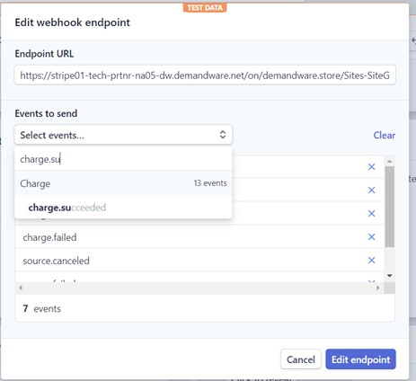

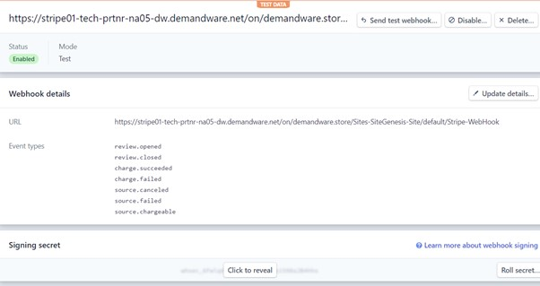

Then copy the signing secret to the ‘Stripe Webhook Signing Secret’ preference.

Make sure that this value is set to your Stripe account country code:



For ApplePay to work, the file RedirectURL.js must be changed with this code:

if

(

URLRedirectMgr

.

getRedirectOrigin

()

===

'/.well-known/apple-developer-

merchantid-domain-association'

)

{

// Intercept the incoming path request

app

.

getView

().

render

(

'stripe/util/apple'

)

;

return

;

}

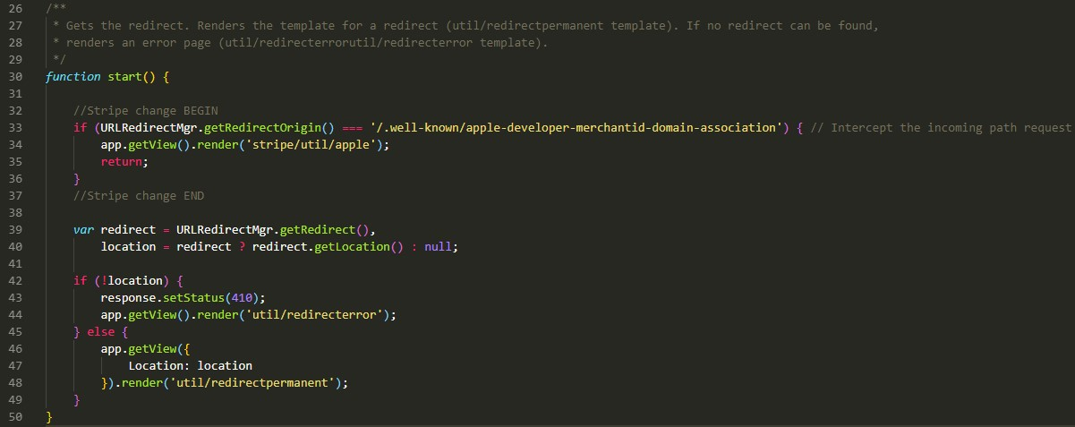

Then you then need to set an alias to one of the sites on the sandbox temporarily so the stripe dashboard can verify the domain. The alias needs to be something like this:

{

"__version"

:

"1"

,

"settings"

:

{

"http-host"

:

"your.sandbox.domain.demandware.net"

,

"https-host"

:

"your.sandbox.domain.demandware.net"

,

"default"

:

"true"

,

"site-path"

:

"/"

},

"your.sandbox.domain.demandware.net"

:

[

{

"locale"

:

"en_GB"

,

"if-site-path"

:

"/"

}

]

}

The locale value needs to be a locale that is not disabled.

Then go to <https://dashboard.stripe.com/account/apple_pay> and click on ‘Add new domain’ button. Enter the domain and download the verification file:

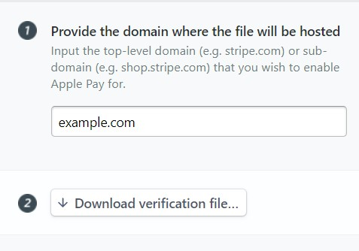

Copy the contents of the file to ‘ApplePay Verification String’ custom preference:

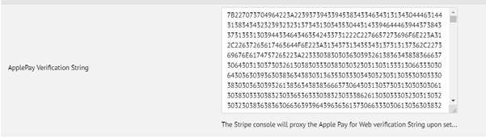

Then click on the ‘Add’ button:

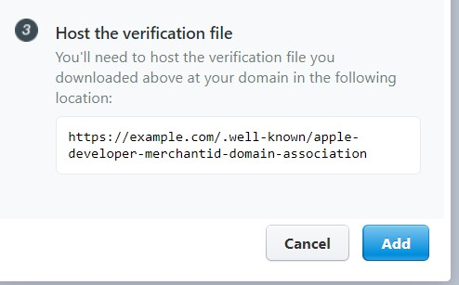

## Custom Code

The base LINK Cartridge code contains support for all credit cards supported by Stripe. Note that the list of allowed cards on the storefront is still limited by the Credit/Debit Cards list in Business Manager (Merchant Tools > Ordering > Payment Methods > Credit/Debit Cards).

Make the following updates to the Storefront Code. Examples provided are based on SiteGenesis version (103.1.11). The initial integration effort should take from ½ to 2 days, based on a SiteGenesis installation. Below are the customizations made to SiteGenesis code.

**Controller: COBilling.js**

app_storefront_controllers/cartridge/controllers/COBilling.js

Add the following if statement to function initCreditCardList()

//Stripe change BEGIN

var

stripeHelper

=

require

(

'int_stripe_core'

).

getStripeHelper

()

;

if

(

stripeHelper

.

isStripeEnabled

()) {

applicablePaymentMethods

=

stripeHelper

.

getStripePaymentMethods

(

applicablePaymentMethods

,

request

.

locale

)

;

}

//Stripe change END

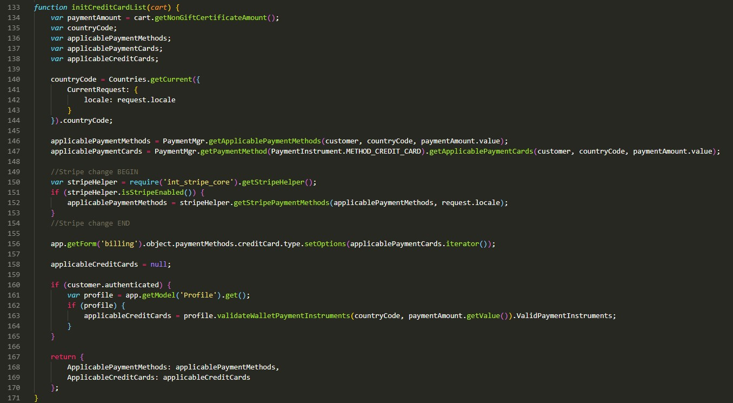

Update billing() / save() function as below:

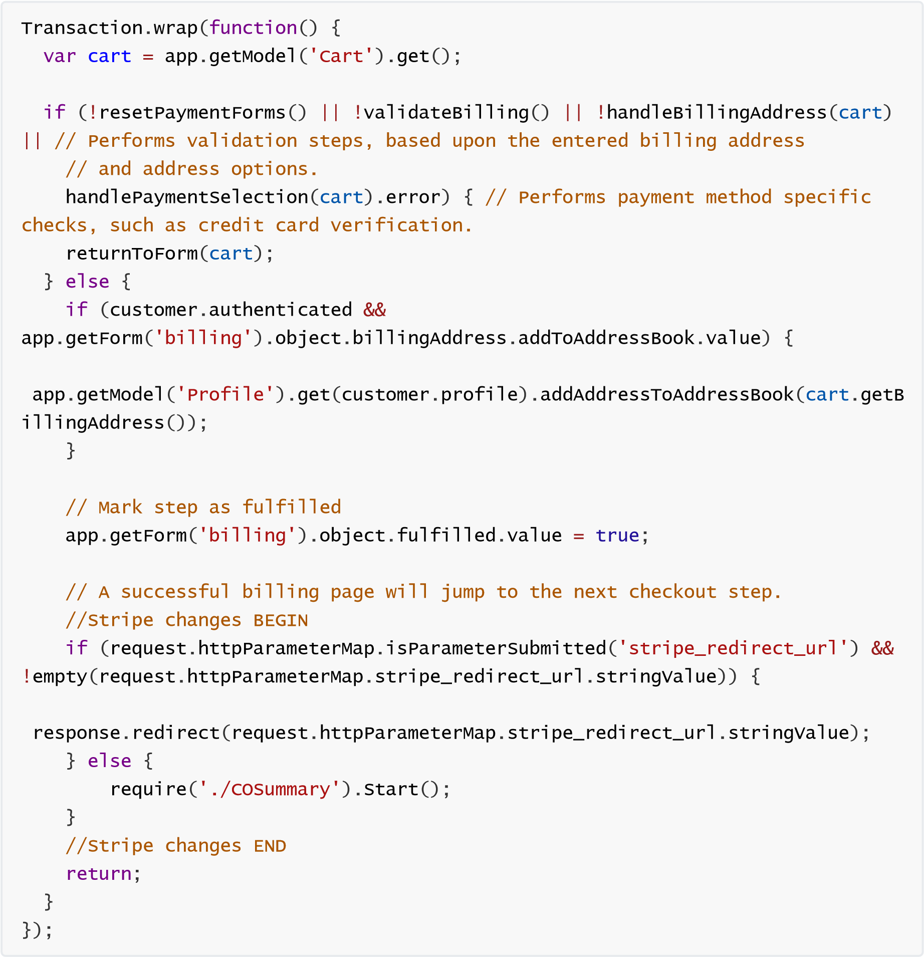

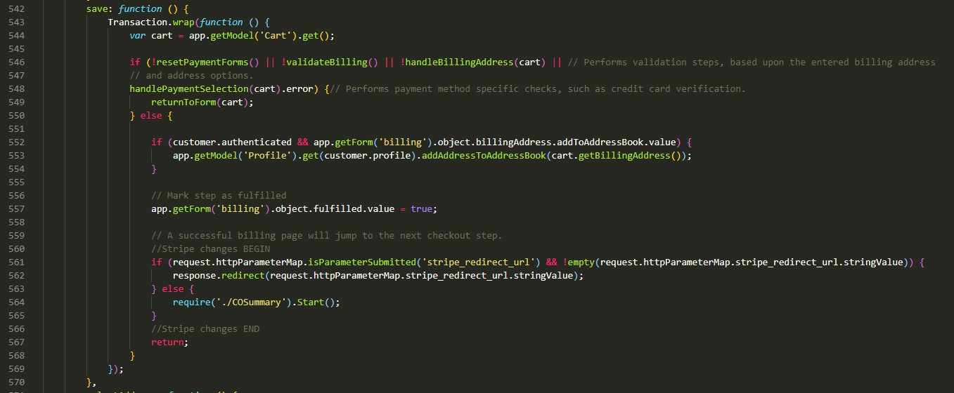

**Controller: COPlaceOrder.js**

app_storefront_controllers/cartridge/controllers/COPlaceOrder.js

Update start() function as below right after this line “var saveCCResult = COBilling.SaveCreditCard();” until the closing parenthesis.

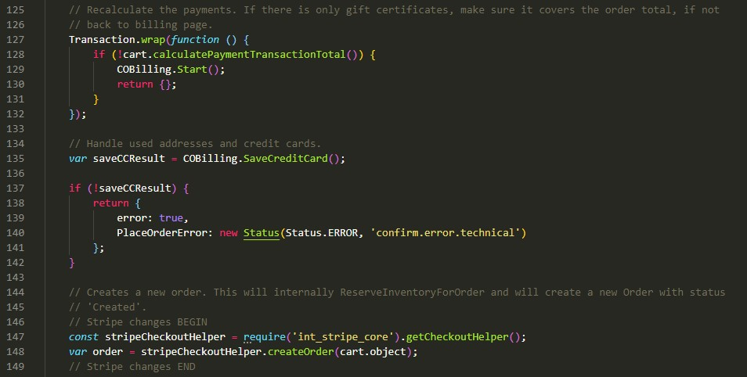

Later down the method after the “else if” block for missing payment info is closed add the following code:

var

isAPMOrder

=

stripeCheckoutHelper

.

isAPMOrder

(

order

)

;

if

(

!

isAPMOrder

)

{

var

stripePaymentInstrument

=

stripeCheckoutHelper

.

getStripePaymentInstrument

(

order

)

;

if

(

stripePaymentInstrument

&&

order

.

custom

.

stripeIsPaymentIntentInReview

)

{

return

{

Order

:

order

,

order_created

:

true

};

}

else

{

var

orderPlacementStatus

=

Order

.

submit

(

order

)

;

if

(

!

orderPlacementStatus

.

error

)

{

clearForms

()

;

}

else

{

stripeCheckoutHelper

.

refundCharge

(

order

)

;

}

return

orderPlacementStatus

;

}

}

else

{

const

Email

=

app

.

getModel

(

'Email'

)

;

const

Resource

=

require

(

'dw/web/Resource'

)

;

Email

.

sendMail

({

template

:

'stripe/mail/orderreceived'

,

recipient

:

order

.

getCustomerEmail

()

,

subject

:

Resource

.

msg

(

'order.ordercreceived-email.001'

,

'stripe'

,

null

)

,

context

:

{

Order

:

order

}

});

return

{

Order

:

order

,

order_created

:

true

};

}

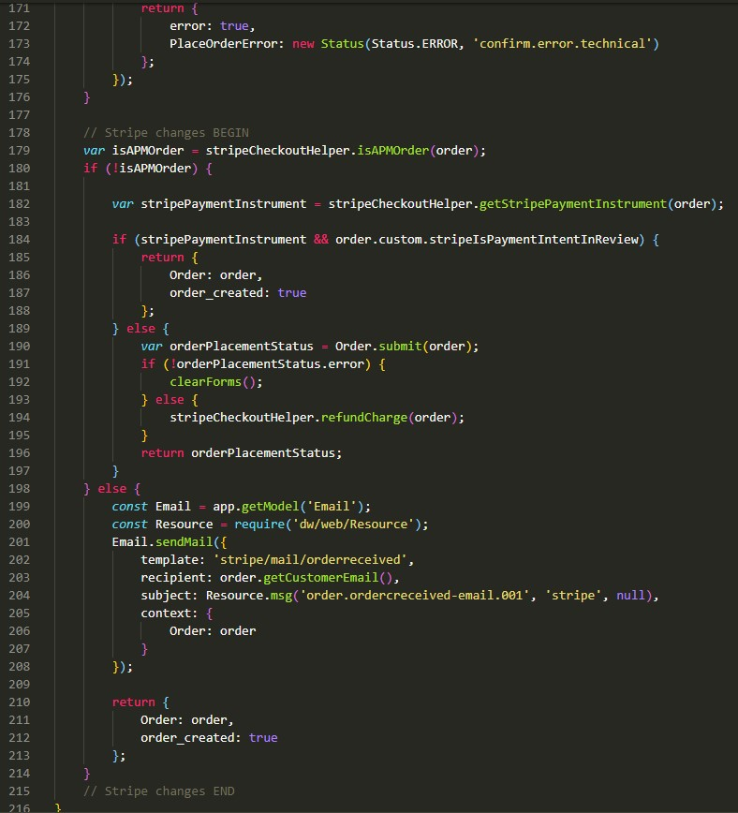

**Controller: COShipping.js**

app_storefront_controllers/cartridge/controllers/COShipping.js

In the function start() after if (cart.getProductLineItems().size() === 0) {

Add this code:

require

(

'./COBilling'

).

Start

()

;

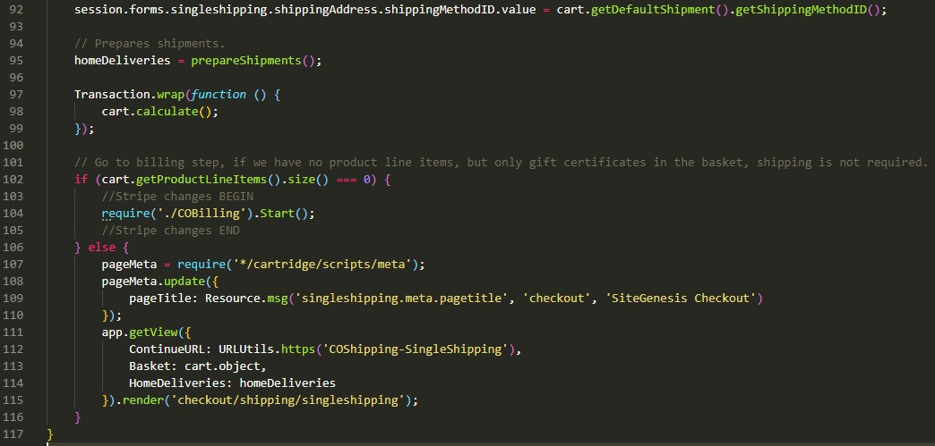

In the function singleShipping() after the line session.forms.singleshipping.fulfilled.value = true;

Add this code:

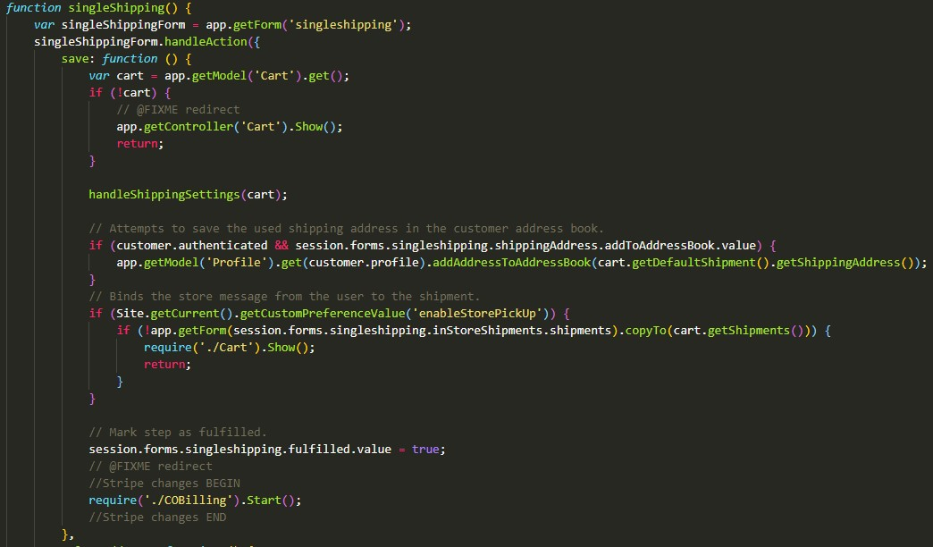

require

(

'./COBilling'

).

Start

()

;

**Controller: PaymentInstruments.js**

app_storefront_controllers/cartridge/controllers/PaymentInstruments.js

Update the list() function as below:

var

stripeHelper

=

require

(

'int_stripe_core'

).

getStripeHelper

()

;

var

paymentInstruments

;

if

(

stripeHelper

.

isStripeEnabled

()) {

var

wallet

=

stripeHelper

.

getStripeWallet

(

customer

)

;

var

paymentInstruments

=

wallet

.

getPaymentInstruments

()

;

}

else

{

var

wallet

=

customer

.

getProfile

().

getWallet

()

;

var

paymentInstruments

=

wallet

.

getPaymentInstruments

(

dw

.

order

.

PaymentInstrument

.

METHOD_CREDIT_CARD

)

;

}

Which should look like this:

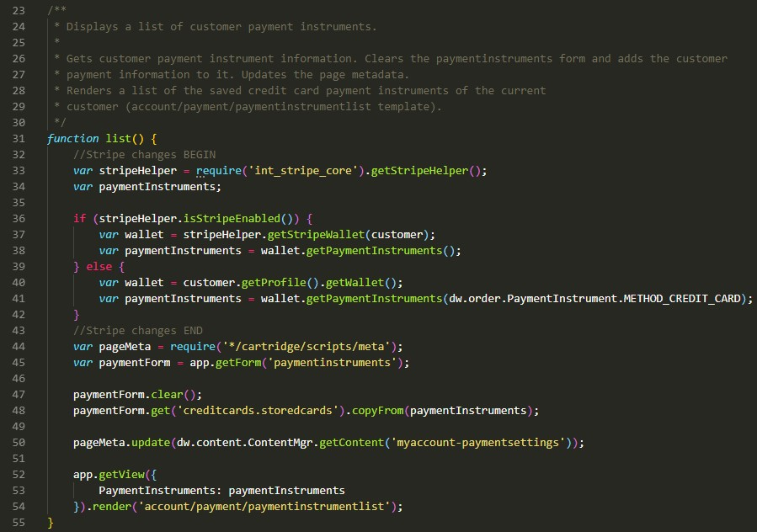

**Controller: RedirectURL.js**

app_storefront_controllers/cartridge/controllers/RedirectURL.js

In the function start add the following code:

if

(

URLRedirectMgr

.

getRedirectOrigin

()

===

'/.well-known/apple-developer-

merchantid-domain-association'

)

{

// Intercept the incoming path request

app

.

getView

().

render

(

'stripe/util/apple'

)

;

return

;

}

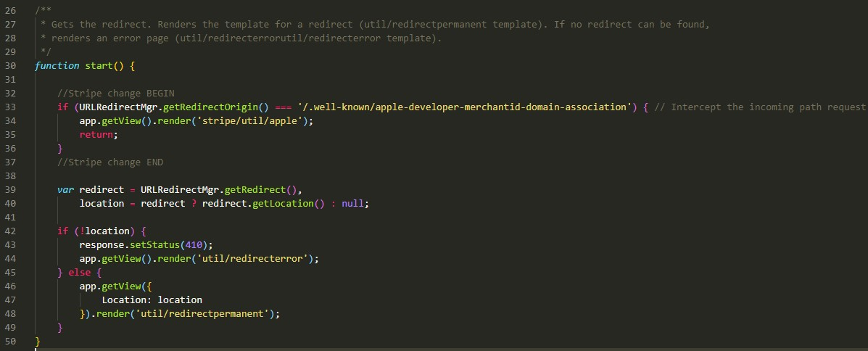

## External Interfaces

Stripe functionality relies heavily on external calls to the Stripe services. All external interfaces use the Service Framework to communicate with the Stripe API.

Stripe accounts are free to create and use. Most communications with Stripe services are logged and easily accessible in the Stripe Dashboard ([http://dashboard.stripe.com)](http://dashboard.stripe.com/). It is highly encouraged to use the Stripe Dashboard to monitor and test your integration.

The main configuration for integration of the Stripe services can be found under **Administration > Operations > Services**

There is a different service for each external call:

* stripe.http.addCard
* stripe.http.authorizePayment
* stripe.http.createCharge
* stripe.http.createCustomer
* stripe.http.deleteCard
* stripe.http.fetchCustomerCards
* stripe.http.fetchCustomerSources
* stripe.http.refundCharge
* stripe.http.retrieveCustomer
* stripe.http.service
* stripe.http.updateCard

All of these services use the same profile and the same credentials. The only thing that may be different is whether or not the communication log is enabled and the log name prefix. Here is the configuration of some of the services:

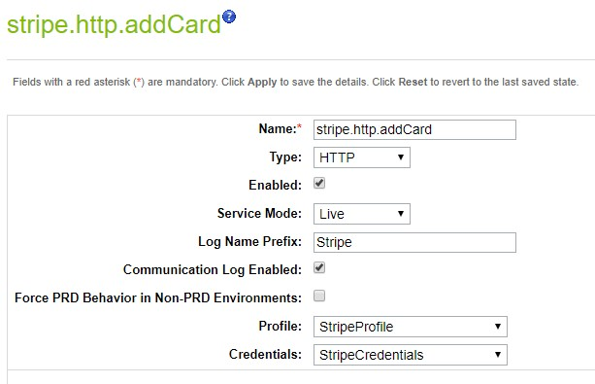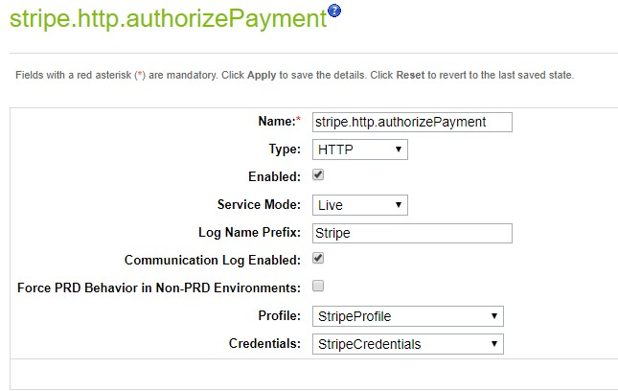

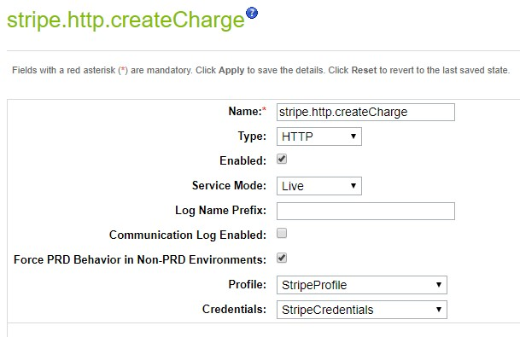

## Firewall Requirements

*No requirements*

## Stripe Payment Element

*Stripe cartridge supports Stripe Payment Element as a Payment Method.*

*The Payment Element is an embeddable UI component that lets you accept up to 18+ payment methods with a single integration.*

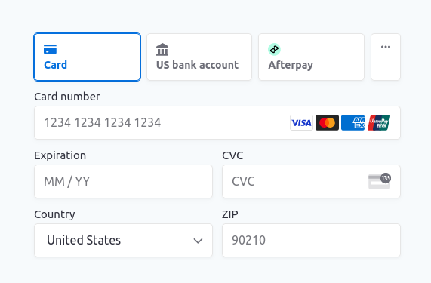

*In order to enable it, Navigate to BM > Merchant Tools > Ordering > Payment Methods and enable the payment method with ID = ‘STRIPE_PAYMENT_ELEMENT’.*

*Then in storefront Checkout > Payment step it will display a widget with all Payment Methods enabled in Stripe Dashboard > Settings > Payment methods (https://dashboard.stripe.com/settings/payment_methods).*

*Note: When The Stripe Payment Element is enabled in Business Manager it can replace all of the other Stripe Payment Methods and you can* *disable ALL of them and use ‘STRIPE_PAYMENT_ELEMENT’ instead.*

*To Enable Payment Method from Stripe Payment Element to be saved for future usage, you need to navigate to Business Manager > Custom Preferences > Stripe Configs > set ‘Stripe Payment Element: Enable Save Payment Method for Future Purchases’ to Yes.*

*Also, to display a list of saved payment methods in checkout, navigate to Business Manager > Payments Methods > Enable ‘CREDIT_CARD’ payment method. When it’s enabled with STRIPE_PAYMENT_ELEMENT, the credit card tab will include a list saved cards (if any).*

*Note: The Stripe Payment Element supports ‘Stripe Link’ as a payment method. To enable it, you need to activate ‘link’ from Stripe Dashboard (Settings -> Payments -> Payment Methods).*

## Stripe Radar Insights Display

*Stripe Radar detects and blocks fraud using machine learning that trains on data across millions of global companies. You can enable Stripe Radar Data (risk score and level) display in BM (screenshot below):*

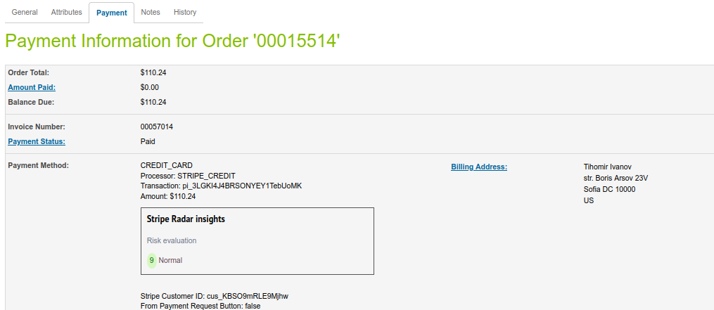

*by navigating to BM > Merchant Tools > Custom Preferences -> Stripe Configs -> then set ‘Risk Score Data’ to ‘Yes’*

## Alternate Payment Methods

*Stripe cartridge supports alternate payment methods. Here is a guide how to use some of them:*

### ACH Debit

*Stripe supports accepting ACH payments—direct from bank accounts—alongside credit cards. ACH is currently supported only for Stripe businesses based in the U.S.*

*So, in Business Manager -> Merchant Tools -> Custom Preferences -> Stripe Configs -> Country Code (Stripe Payment Request Button) should be ‘US’ in order to be able to use ACH Debit.*

*In order to Enable the ACH Debit as payment method, login to your Business Manager, select a site and navigate to Merchant Tools > Ordering > Payment Methods, then Enable payment method with ID = ‘STRIPE_ACH_DEBIT’.*

*Once the ACH Debit payment method is enabled, it will enable the ACH Debit form as part of the checkout:*

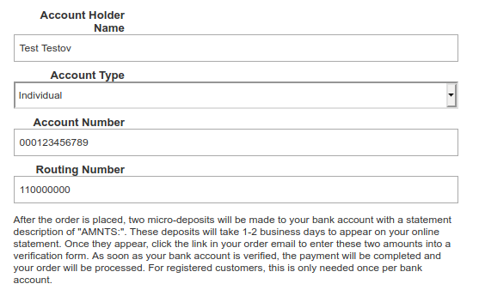

*When a customer places an order with ACH Debit, it will initialize the following Order custom attributes:*

* ‘Stripe payment intent in review’ is Checked (until payment is confirmed by the client)
* *‘Stripe Bank Account Token’*
* *‘Stripe Customer ID’*

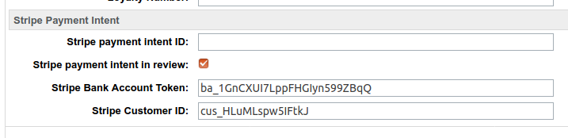

*Please Note: Before you can create an ACH charge, you must first collect and verify your customer’s bank account and routing number.*

*The cartridge comes with such form where customer can enter ach debit confirmation information that can be modified additionally during Stripe ACH Debit integration.*

*You can copy files from:*

*documentation/ach_debit_complete_order_Controllers*

*to*

*cartridges/app_stripe_controllers/cartridge/controllers/AchDebit.js*

*cartridges/app_stripe_core/cartridge/forms/default/achdebitcomplete.xml*

*cartridges/app_stripe_core/cartridge/templates/default/ach-debit-complete-form.isml*

*to see the form:*

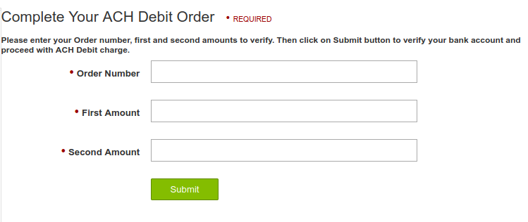

*Please Note: The form is public available by default. So, you may need to restrict that access.*

### WeChat Pay

*Stripe supports accepting WeChat pay payments, a popular payment method in China.*

*In order to Enable the WeChat as payment method, login to your Business Manager, select a site and navigate to Merchant Tools > Ordering > Payment Methods, then Enable payment method with ID = ‘STRIPE_WECHATPAY’.*

*Once the WeChat Pay payment method is enabled, it will display the WeChat as a payment method in the checkout and an WeChat QR code at the last step of Order confirmation page:*

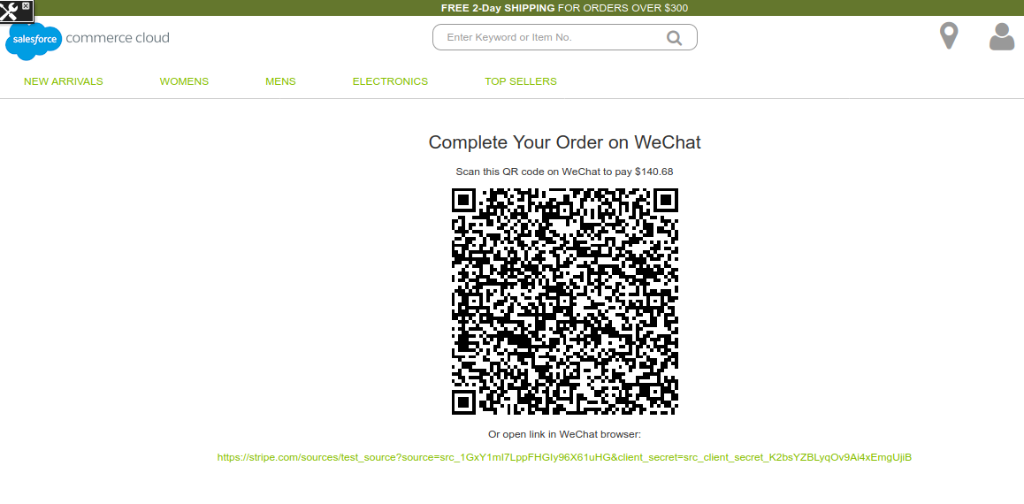

*Please Note: the QR Code URL will be stored as an Order custom attribute (stripeWeChatQRCodeURL):*

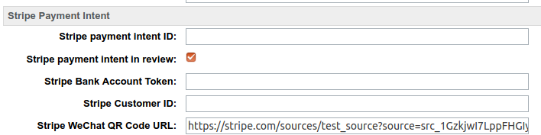

*The WeChat order will be marked as under review (‘Stripe payment intent in review’ will be checked) until payment is completed on WeChat side and a webhook notification is sent to SFCC which will update the payment.*

### Klarna

*Stripe supports Klarna payments for countries where Klarna is supported.*

*In order to Enable Klarna as payment method, login to your Business Manager, select a site and navigate to Merchant Tools > Ordering > Payment Methods, then Enable payment method with ID = ‘STRIPE_KLARNA’.*

*Once the Klarna payment method is enabled, and in checkout customer selects ‘Klarna’ it will display Klarna widget:*

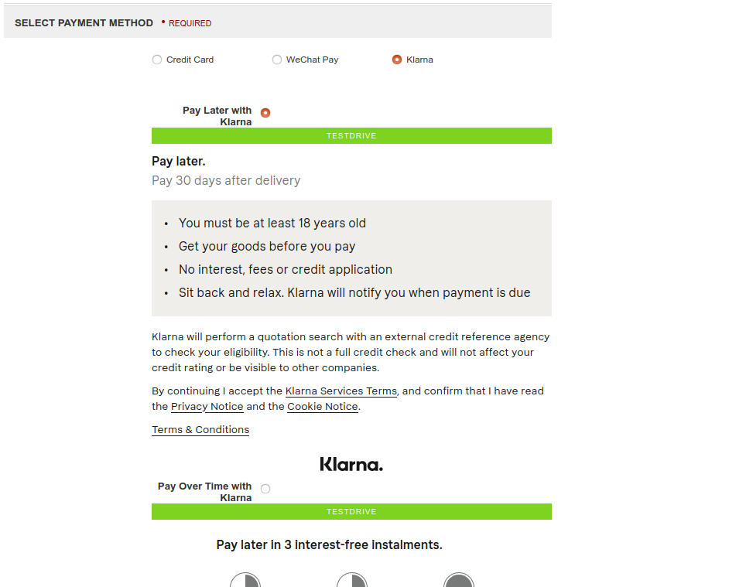

*The Klarna order will be marked as under review (‘Stripe payment intent in review’ will be checked) until payment is completed when a webhook notification is sent to SFCC which will update the payment.*

### Multibanco

*Stripe cartridge supports payments using Multibanco, the most popular payment method in Portugal.*

*Stripe users in Europe and the United States can accept Multibanco payments from customers in Portugal.*

*In order to Enable Multibanco as payment method, login to your Business Manager, select a site and navigate to Merchant Tools > Ordering > Payment Methods, then Enable payment method with ID = ‘STRIPE_MULTIBANCO’.*

*Then the Multibanco payment method will be displayed in Checkout only for Euro currency.*

*When customer selects Multibanco in Checkout and click to proceed, he/she will be redirected to Stripe page where to confirm the payment.*

*Please note: the order will be created on SFCC side with payment status ‘Not paid’ until Stripe sends webhook notification for the order. Once the webhook is processed by ‘Stripe – Process Webhook Notifications’ job, the payment status will be changed to ‘Paid’.*

## Manage Refunds

*You can issue refunds (full or partial from BM custom page). Here is how to configure it:*

*1. Login to your Business Manager*

*2. Go to Business Manager > Administration > Organization > Roles & Permissions ->* Administrator -> ‘Business Manager Modules’ Tab -> Select ‘Sites’ -> Check ‘Stripe Payments Refund’ and Save changes

5. Navigate to Business Manager -> Administration -> Stripe -> Stripe Payments Refund

*Enter Order ID and amount to refund, i.e.*

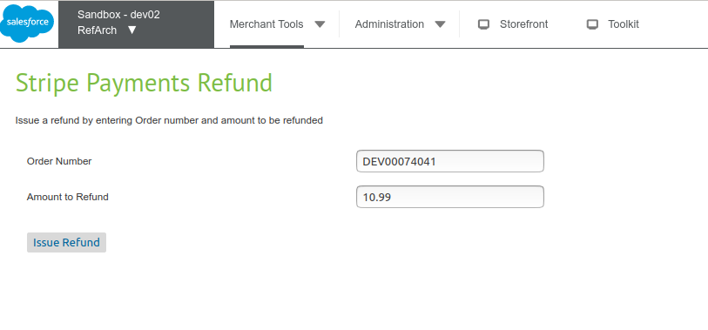

*then click on ‘Issue Refund’ button. It will make an API call to Stripe for the refund.*

*Also, once a refund is issued (from SFCC BM side or from Stripe Dashboard), Stripe will send a ‘charge.refunded’ webhook notification. It will be handled by the cartridge and processed with ‘Stripe - Process Webhook Notifications’ Job which will add an note to the Order with the refunded amount.*

## Gift Certificates

*Stripe integration supports SFCC Gift Certificates redemption (Full and Partial) for both SiteGenesis and SFRA based implementations.*

*Please Note: SFRA does not allow a customer to use Gift Certificates as a payment method by default. You can use a Proof on Concept cartridge to add Gift Certificate form in SFRA:*

*https://github.com/tishonator/link_stripe_giftcert_redeem_sfra*

# Testing

Please, find more details on the test case document in the same folder.

# Operations, Maintenance

## Data Storage

*The Stripe LINK cartridge extends Commerce Cloud to store several data points.*

*Customer Profile: Stripe Customer ID, used to retrieve information about the customer’s record in your Stripe account.*

1. *stripeCustomerID(string) - Store Stripe customer ID*

*Order/Basket Custom attributes*

1. *stripeIsPaymentIntentInReview(Boolean) - Store payment intent in review*

*Payment Transaction custom attributes*

1. *stripeChargeId(string) - Store charge id*
2. *stripeChargeOutcomeData(text) - Store charge outcome data*
3. *stripeClientSecret(string) - Store client secret*
4. *stripeJsonData(text) - Store webhook JSON data*
5. *stripeOrderNumber(number) - Store order number*
6. *stripeSourceCanCharge(boolean) - Store if Stripe source can be charged*
7. *stripeSourceId(string) - Store Stripe source ID*

*Payment Transaction custom attributes*

1. *stripeChargeId(string) - Store charge ID*
2. *stripeCardID(string) - Store card ID*
3. *stripeCustomerID(string) - Store customer ID*
4. *stripeDefaultCard(boolean) - Store Stripe default card*
5. *stripeClientSecret(string) - Store client secret*
6. *stripePRUsed(boolean) - Store payment request button used*
7. *stripeSavePaymentInstrument(boolean) - Store save payment instrument*
8. *stripeSourceID(string) - Store Stripe source ID*

*Custom Objects: In Business Manager, navigate to the Merchant Tools > Custom Objects > Custom Objects. Below custom object is there.*

1. *StripeWebhookNotifications*

*Custom Site Preferences: noted in detail above (section Configuration).*

## Availability

Please refer to the Stripe Service Level Agreement <https://stripe.com/legal>to determine specific up-times for the service. In case the service fails, there is no fail-over to allow transactions to proceed. Users will instead be provided with friendly error messaging.

## Failover/Recovery Process

If the Stripe service is unavailable the user will not be able to checkout.

The service availability can be tracked in SFCC using the Service Status.

## Support

[For defects or recommendations on improvements, please contact Stripe Support (https://suppor t.stripe.com).](https://support.stripe.com/)

# User Guide

## Roles, Responsibilities

There are no recurring tasks required by the merchant. Once configurations and job schedules are set up, the functionality runs on demand.

## Business Manager

Business Manager settings and configuration notes are described in detail in the Configurations section.

There are 2 jobs coming with the cartridge:

* Stripe - Delete Custom Objects
* Stripe - Process Webhook Notifications

Enable the job “Stripe - Process Webhook Notifications” for the desired site:

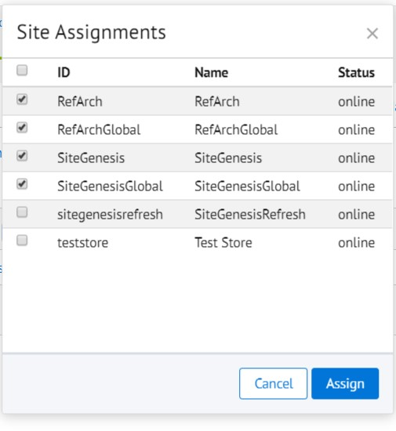

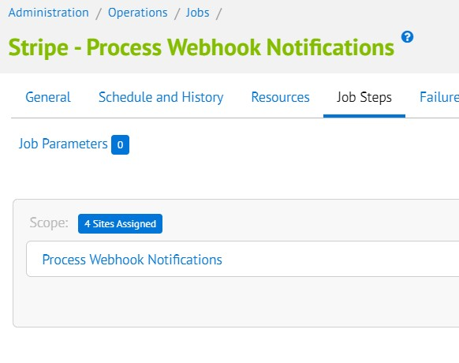

## Storefront Functionality

Credit Card Tokenization

Stripe.js credit card tokenization requires the inclusion of JavaScript on the payment forms, both during Checkout > Billing as well as My Account > Saved Payment Instruments. Additionally, the credit card ‘type’ form fields are automatically detected and updated rather than requiring user selection.

Saved Credit Cards

When an authenticated customer selects a saved credit card on the Checkout > Billing page, they will see a list of their Stripe-saved payment Sources as radio buttons rather than the default SiteGenesis select options.

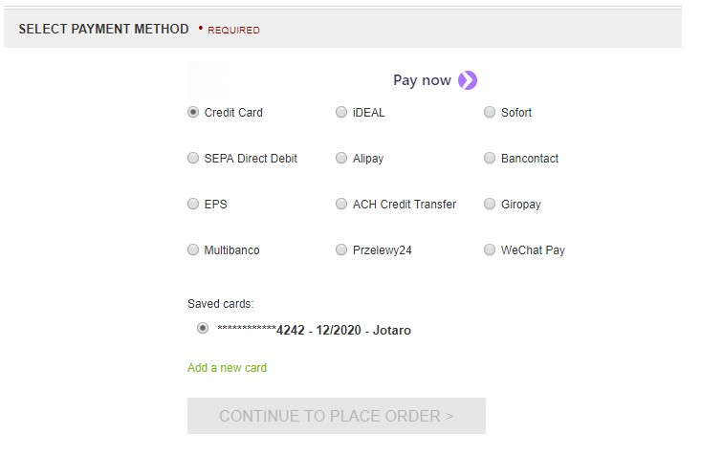

Payment request button

When a customer has a saved address and credit card information in their browser they see the payment request button (Pay Now). The Payment Request Button Element gives you a single integration for Apple Pay, Google Pay, Microsoft Pay, and the browser standard Payment Request API.



Customers see the button above or an Apple Pay button, depending on what their device and browser combination supports. If neither option is available, they don’t see the button. Supporting Apple Pay requires [additional steps](https://stripe.com/docs/stripe-js/elements/payment-request-button" \l "verifying-your-domain-with-apple-pay), but compatible devices automatically support browser-saved cards, Google Pay, and Microsoft Pay.

# Known Issues

The LINK Cartridge has no known issues.

# Release History

|  |  |  |
| --- | --- | --- |
| **Version** | **Date** | **Changes** |
| 22.2.0 | 2022-07-01 | Integrate Integrating Radar insights display in Order Payments in BM |
| 22.1.0 | 2022-06-02 | Add Stripe Payment Element as a Payment Method |
| 20.1.0 | 2020-02-01 | Update documentation to match the new Salesforce template |
| 18.1.0 | 2019-04-15 | Update to use Stripe elements, sources, payment request button, webhooks and asynchronous payments |
| 16.1.0 | 2019-07-30 | Initial release |